NodeJS and HandleBar

Adapted from [Handlebars and Node.js (tutorial) | by Raja Raghav | Programming sage | Medium](https://medium.com/programming-sage/handlebars-in-node-js-tutorial-a30a41fc6206)

# Configuration

Our final directory folder will be like this

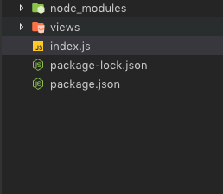

1. Create a project using *npm init*
2. Install express and save it as a dependency using *npm i --save express*
3. Install hbs and save it as a dependency using *npm i --save hbs*

# Code

## index.js

const app = require("express")();

var path = require("path");

//view engine setup

app.set("views", path.join(__dirname, "views")); //setting views directory for views.

app.set("view engine", "hbs"); //setting view engine as handlebars

app.get("/", (req, res) => {

let peopleList = getRandomList();

res.render("index", { people: peopleList }); //passing list of people to our index.hbs file.

});

let getRandomList = () => {

let list = ["ada", "turing", "lovelace", "neumann", "gracehopper"];

let limit = Math.floor(Math.random() * (list.length - 1 - 0) + 0); //generating random number between 0 & 4

return list.slice(limit);

};

app.listen(5000);

# index.hbs

<!DOCTYPE html>

<html>

<body>

<ul>

{{#each people}}

<li>{{this}}</li>

{{/each}}

</ul>

</body>

</html>

# Run the app

node index.js

Output:



# Challenge

Follow a more complex tutorial about HandleBar

[Create Website With Handlebars Express - NodeJS | Geekstrick](https://www.geekstrick.com/create-website-with-handlebars-express-nodejs/)